**EE 316 - Electronic Design Project**

Project: P2

**DC Motor Speed Controller**

**First Project Report**

25 Nisan 2022

**Objective**

DC motors are directly or indirectly connected with many products we use. The characteristics of the engine used are important for the desired action to be performed. The feature to focus on here will be to control the speed of the motor. While our aim is to control the speed of the motor, it will be to choose the response time, the average power used and the control components most suitable for our purpose. Our aim is to rotate the dc motor at 3 different rpm. For this, we will use a method called PWM. PWM means pulse width modulation and it will allow us to get signals in the desired range at the output by controlling the widths of the pulses. The general working principle of the dc motor speed control circuit we want to design will be to control the power with square waves.

**Group Members**

**Common efforts:** DC Motor Speed Control

**Emirhan Yorulmaz - 260206058**

**Ferhat Böcek - 260206070**

**Hüseyin Kaan Türk - 240206031**

**1. Background Information**

**1.1. DC Motors**

The main purpose of our project is to rotate the dc motor at certain speeds and to adjust the rotation speed at 3 different rpm values. A standard DC motor is sufficient for this. After all, the general working principle is to convert electrical energy into mechanical energy that works at desired intervals. In order to take the mechanical energy from the dc motor and control it, we used a 16-hole disc attached to the rotor end. While the perforated disk rotates between the IR Led and the phototransistor, the signal emitted by the IR Led will pass through the holes of the disk and fall on the sensor, thus enabling us to produce the frequency corresponding to the rotation speed of the motor. In short, the purpose of using a DC motor is to generate the signal required to control the motor and to use this signal in a feedback system with the PWM method.

**1.2. Phototransistors**

Phototransistors are circuit elements that produce current depending on the light falling on them. It is a sensitive type of sensor. When light falls on the base terminal, the resistance value between the collector and the emitter decreases and they start to pass current. We chose to use phototransistors because they offer an acceptable speed and respond faster than photodiodes. We hope that the phototransistor we want to use will be sensitive and react quickly. When the DC motor is running, the light emitted from the IR LED will trigger the sensor by passing through the perforated disk. This will produce current with light falling on the phototransistor. This current will be our signal that we will use during the circuit. We need to produce 3 different signals for 3 different rotational speeds. We preferred a standard sensor to produce signals at different frequency values. We have established 3 DC resources to represent the phototransistor in order to achieve the experiment on simulation programs. In this way, we set the frequency, amplitude and time delays of the resources to ensure that DC resources serve as a phototransistor.

**1.3. Converters**

Converters are various components or circuits that provide input and desired output. In accordance with the subject we will study, we must obtain the voltage output proportional to the frequency and pulses coming from the sinusoidal wave we provide. When we supply a signal through a frequency to voltage converter circuit, we will get a proportional DC output[1]. Circuits can be built using a variety of methods and different components to achieve frequency-to-voltage conversion. LM2907-LM2917 frequency to voltage converter IC, which is widely used, easy to obtain and whose outputs can be interpreted easily, can be preferred.

We designed two circuits for frequency to voltage conversion. In the first circuit, we converted the sinusoidal signal representing each different rotation speed of the motor from sine to square wave using LM741 op amp. The square wave will go to the trigger leg of the 555 timer circuit we use as a multivibrator and will be converted to dc voltage by passing through a comparator op amp in the timer. We aim to obtain 3 different dc voltages and for this, LM741 and timer 555 gave us the results we wanted for the first circuit. Alternatively, we used the LM 2917 IC in the second circuit we designed. With this IC, we performed both sine to square wave conversion and frequency to voltage conversion. We achieved our output values at the desired intervals in almost both circuits.

**1.4. Pulse Width Modulation Technic**

PWM (Pulse Width Modulation) is a modulation technique that allows to generate analog signals using signals from digital sources[2]. The resulting PWM signal is basically a square wave that switches between on and off. The frequency and duty cycle of the PWM signal allow us to learn about the behavior of the signal. PWM technique is commonly used to motor speed control, generating analog voltage levels and for generating analog waveforms. We generate the required input signal for the PWM circuit by taking the difference in the motor voltage with the potentiometer voltage. Thus, we created the necessary PWM signal for a feedback system. In other words, we have used the PWM method to encode the amplitude and duty cycles of another signal to the pulse width or time of another signal.

**1.5. IC Drivers**

In electronics, a driver is a circuit or component used to control various transistors, LCD displays, stepper motors, and similar circuits and components. In this process, we will work on motor driver ICs. A motor driver IC controls the direction of the motor according to commands or instructions it receives from the controller. Many motor drivers follow different topologies, the most popular being the H-bridge topology.

**1.6. BCD Counters**

Binary Coded Decimal(BCD) Counters use for counting every up/down edges of given signal. The condition of posedge or negedge depends on IC but in this process we used up-counting. In this process, we used 4553 IC for 3 digit BCD counting[3]. This IC requires a clock signal, a leech enable, an input signal and a reset. For clock signal, we need another timer circuit (NE555 can be used with 375ms). Our input signal will be obtained by circuitry. This counting process can be viewed simultaneously in display. To obtain this display we use 4511 IC to convert 4-digit output of 4553 into 7-digit output of 4511. This conversation allow us to use 7-segment display LEDs. With help of 3 LEDs we can count 120 to 300.

**2. Methods and Proposed Solutions**

**2.1 Overview**

We used a phototransistor in the circuit to represent the rotational speed of the DC motor in terms of frequency. We obtained signals with different frequency values at 3 different rotation speeds. These signals looked almost like sinusoidal signals. We represented the rotational speed of the DC Motor at 1200, 2000 and 3000 RPM using IR light passing through the perforated disk. Then, we were able to generate 3 signals at 320, 533 and 800 Hz using the phototransistor sensor as a switch. Since phototransistors produce higher current in the wavelength range of 750-1000nm, we used the appropriate voltage and current values from the data sheet of a phototransistor, which is generally preferred. We defined these values using 3 different sources through Proteus and LTspice programs.

To represent the 3 different rotational speeds requested, we passed low wavelength light through the perforated disk connected to the DC motor shaft. Thus, as the perforated disc continues to rotate, light will fall on the sensor in the form of pulses and the phototransistor will be triggered to produce sinusoidal signals. Then we converted the sinusoidal signals to square wave. We used a LM741 op amp to convert it from sine to square wave. This square wave input signal was then converted from frequency to voltage. We amplified 3 different dc voltages with LM741 op amps. Then we used a differential op amp to generate the error signal and obtain the necessary input signal for the PWM circuit. Here, we have produced the necessary error signal for the PWM circuit by taking the difference between the potentiometer voltage and the motor voltage. The error signal contains the speed information, duty cycle and frequency information required for PWM. We sent this signal to the motor driver circuit after the PWM circuit. The motor driver circuit will use the PWM signal to generate the power that will enable us to rotate the motor at the RPM values ​​we have previously determined. Finally, in order to determine the rotation speed of the motor, the square wave we produced from the output of the LM741 op amp will be the input signal of the BCD counter circuit. And it will show 3 different rpm values ​​on a 16-digit display.

Figure 1 : Block diagram of the project.

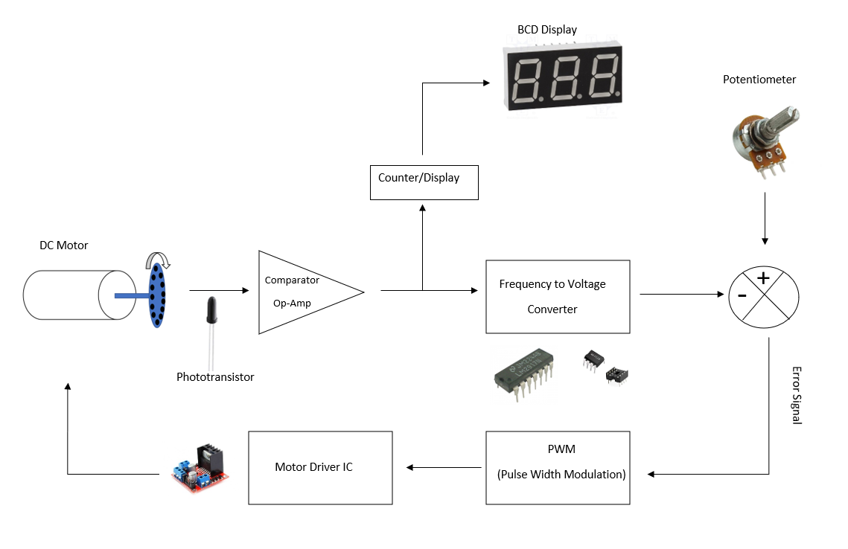

**2.2. Calculate and Create Desired Sinusoidal Source Signal**

To create our signal, we must first know the source and output characteristics of our signal. Our signal source will be a phototransistor and will provide sinusoidal signal. There are 16 holes on the disc connected to the DC motor, and a pulse will be observed for each hole detected by the phototransistor. In line with these numbers and the amplitude values for the phototransistor, a sinusoidal signal should be created for the desired 1200-2000-3000 rpm values and the frequency values should be calculated. These frequency values are 320-533.33-800 Hz as a result of calculations. Sinus waves will be created with these frequency values and will be used as our signal source in the beginning. In Figure 2, you can observe 3 signals with added delay times, one after the other.

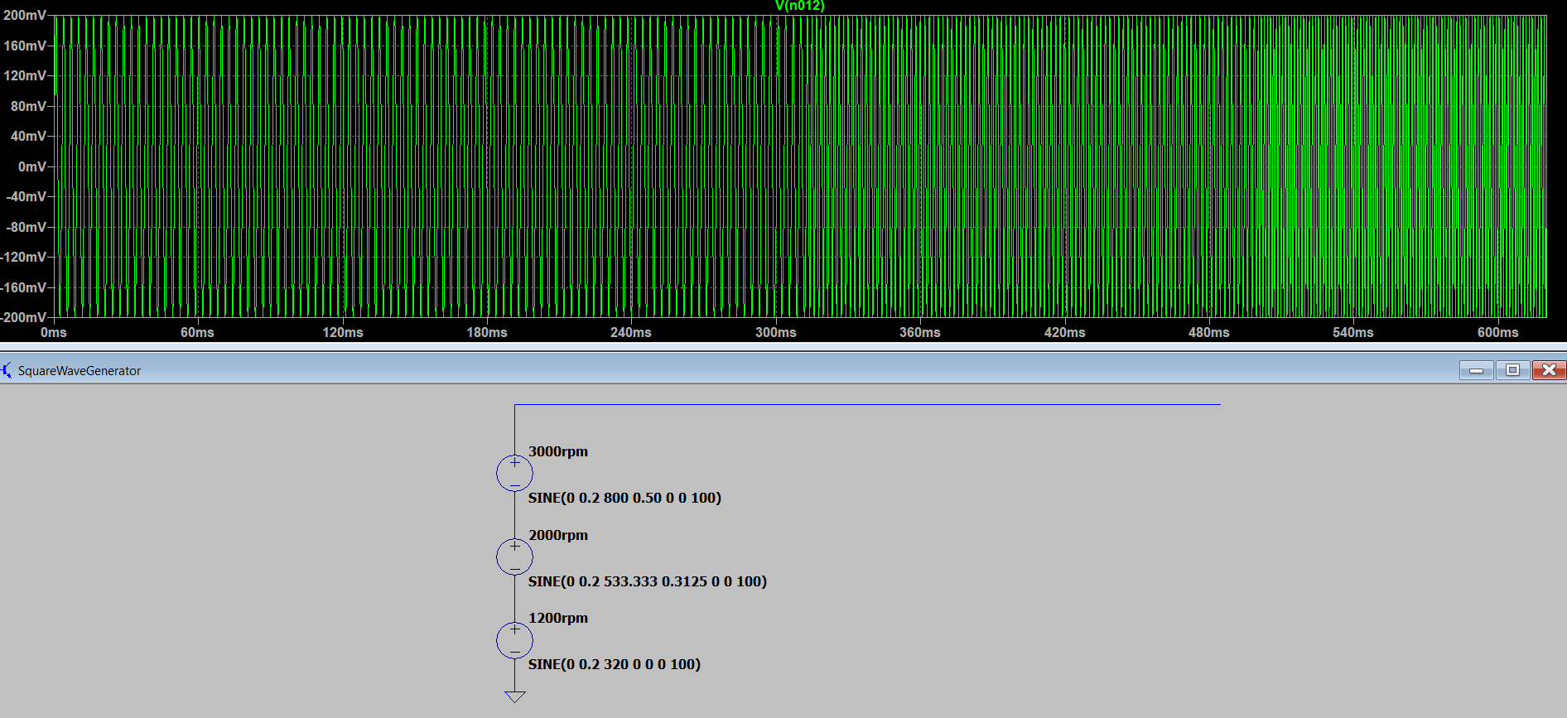

Figure 2: Sinusoidal input signals.

**2.3. Sinusoidal to Square Wave for Digital Part (BCD Counter)**

For the digital part, which will print the RPM values according to the frequency values of the signal, our signal should be converted to square wave format. This process can be created using a number of methods. A square wave generator can be designed using a comparator amplifier, which is one of these methods. Op-amp comparators generate an output signal by comparing an analog voltage level with another analog voltage level to be compared[4]. In Figure 3, you can observe the comparator circuit and the signal graph obtained afterwards. This converted square wave signal will be input of our BCD counter. Each peak value will counted, then the count number will be displayed at 3 digit display.

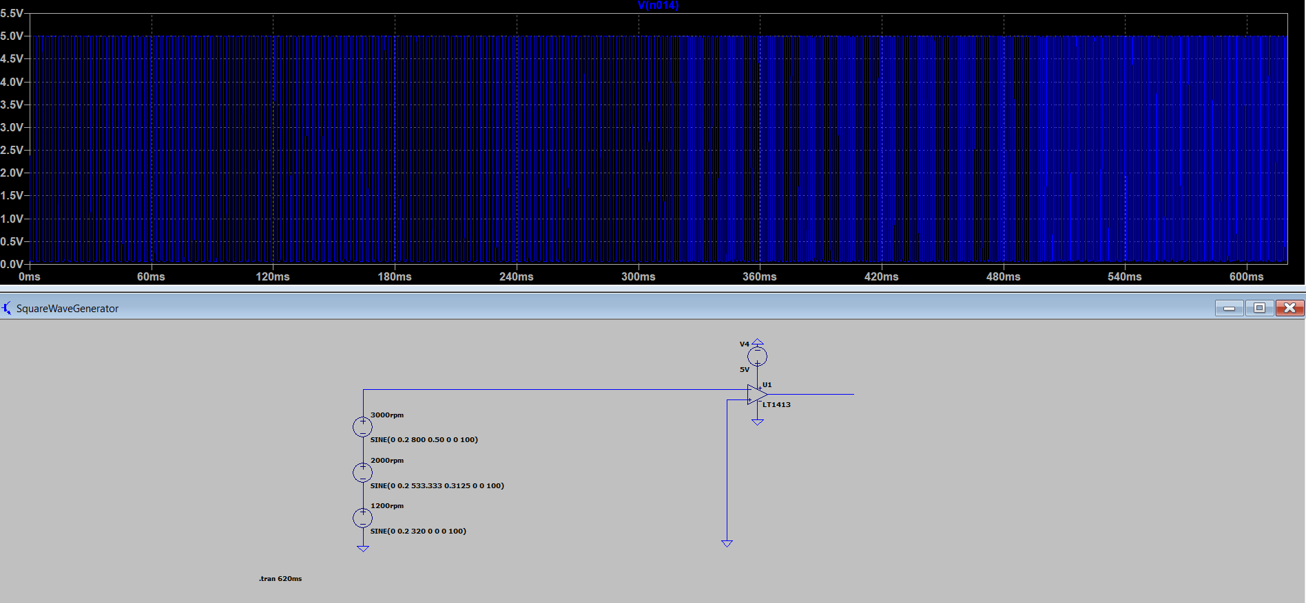

Figure 3 : Square wave output of comparator circuit.

**2.4. Frequency to Voltage Converter Process**

The information of our input signal is available as frequency, but in order to create the error signal and control the motor speed, the voltage values ​​corresponding to these frequency values ​​must be reached. Different methods can be applied for this process. Timer 555 and LM2917 with frequency to voltage integration are two of them. The frequency values ​​from the input can be interpreted with the monostable circuit to be created with the Timer 555 integrated[5]. In Figure 4, DC output of the converter circuit designed with timer 555 IC can be observed. The LM2917 IC will receive sinusoidal input as input. It will produce a square wave with the comparator op-amp inside and will enable us to create a DC output with the charge pump circuit. The LM2917 IC is an IC that is not in the LTspice library. For this reason, the circuit is designed over the Proteus program, as can be seen in Figure 5.While designing these circuits, some important factors should be considered. One of them is the response time[6]. Response time is important in order to observe fast results in motor control. The other important thing is that our output should be limited to certain voltage values ​​because our output value dc voltage will be used to find the error signal.

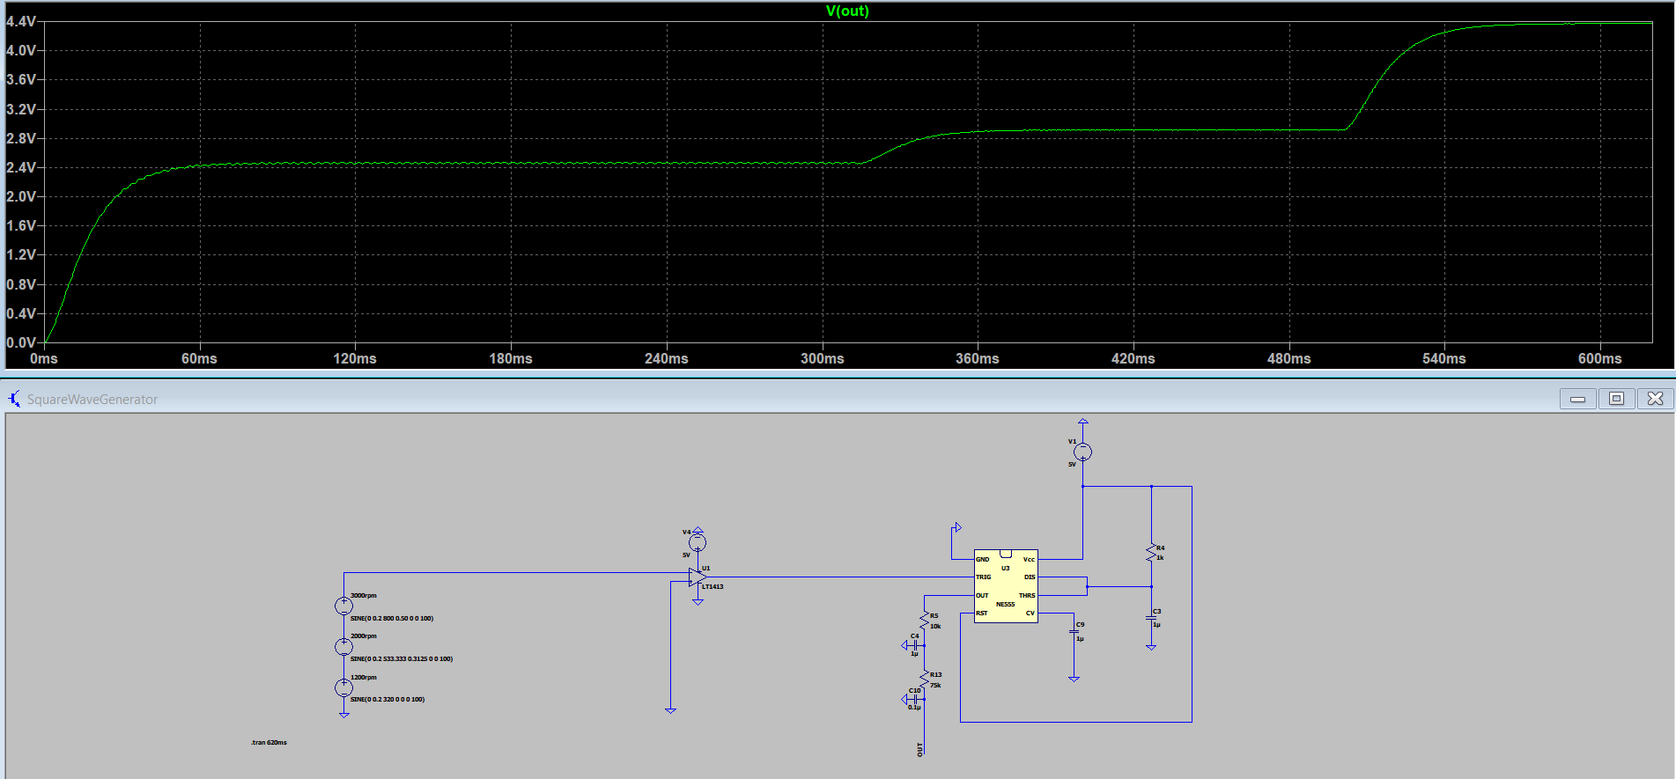

Figure 4 : Frequency to voltage converter output designed with Timer 555 IC.

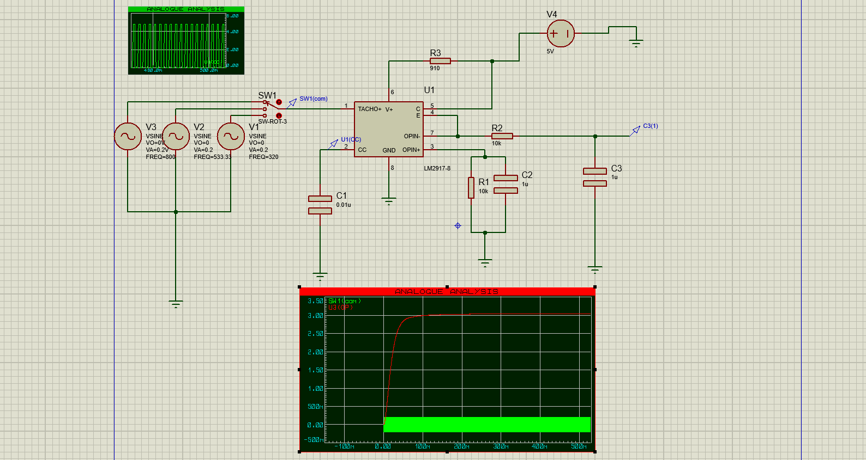

Figure 5 : Frequency to voltage converter output designed with LM2917 IC.

**2.5. PWM(Pulse Width Modulation)**

We managed to set up two different circuits until the PWM circuit stage. We made our first circuit with LM741 op amps and 555 timer circuits. In our second circuit, we used the LM2917 IC. In the first circuit, we converted the sinusoidal signal produced by the sensor into a square wave with LM741 op amps. Then we used the timer 555 integrated as a monostable multivibrator. There was a lot of ripple in the dc outputs we got. To get rid of these fluctuations, we installed a low-pass filter circuit at the output of the timer 555 circuit. In order to obtain a sharper and fluctuating dc signal, we built two RC circuits and thus we obtained 3 different dc voltages with appropriate time delays. We boosted these dc voltages again using LM741 op amps. We got 4.80V, 3.20V and 2.70V from the output of our amplifier circuit for the frequency values ​​of 800 Hz, 533 Hz and 320 Hz, respectively. Likewise, we have obtained close values ​​from the amplifier outputs in the LM2917 circuit. Finally, after taking the difference between the pot voltage and the motor voltages, we set up the PWM circuit. PWM circuit includes differential amplifier, Schmitt trigger, integrator and comparator. Schmitt trigger and integrator generate triangle wave. The comparator circuit generates the PWM signal by comparing the triangle wave with the dc voltage. The duty cycle of the signal to be produced as a result of this comparison is changed.

**2.6. IC Driver**

Our main goal in our dc motor speed control project is to use dc motor as efficiently as possible. We can only achieve this by controlling the number of revolutions of the engine with different methods. By using IC drivers, it is possible to run motors efficiently with lower energy. Our aim in this project is to control the motor driver with PWM signals and run the motor with low energy consumption but high efficiency. We used half bridge IC motor driver for motor driver. While the transistors in the half-bridge circuit enable us to amplify the signal, the diodes are used for protection so that the current flowing during the rotation of the motor does not burn the circuit.

**References**

[1] Wikipedia article on "**Multivibrator**"

<http://en.wikipedia.org/wiki/Multivibrator>

[2] ‘’Pulse Width Modulation’’

<https://www.electronics-tutorials.ws/blog/pulse-width-modulation.html>

[3] “How to build a 4511 BCD to 7 Segment Decoder Circuit”

<http://www.learningaboutelectronics.com/Articles/4511-BCD-to-7-segment-display-decoder-circuit.php>

[4] “Op-Amps Comparator Circuit”

<https://www.renesas.com/us/en/support/engineer-school/electronic-circuits-03-op-amps-comparator-circuit>

[5] ‘’555 Timer’’

<https://www.electronics-tutorials.ws/waveforms/555_timer.html>

[6] ‘’Frequency to Voltage Converter Circuits’’

<https://www.electronics-tutorials.ws/waveforms/monostable.html>